Worksheet for Ethical Deliberation

This worksheet has been designed to assist advisers to make professional and ethically responsible decisions, by encouraging them to think about their own ethical standards in a professional context, and reflecting on the following questions:
- What are ethics? Why are they important?
- What ethical behaviours do I think are important to display as an adviser?
- How do my decisions affect my clients and others?

Methodology
With reference to the flowchart below, write under each heading the relevant points that apply to the ethical situation that you are trying to resolve.

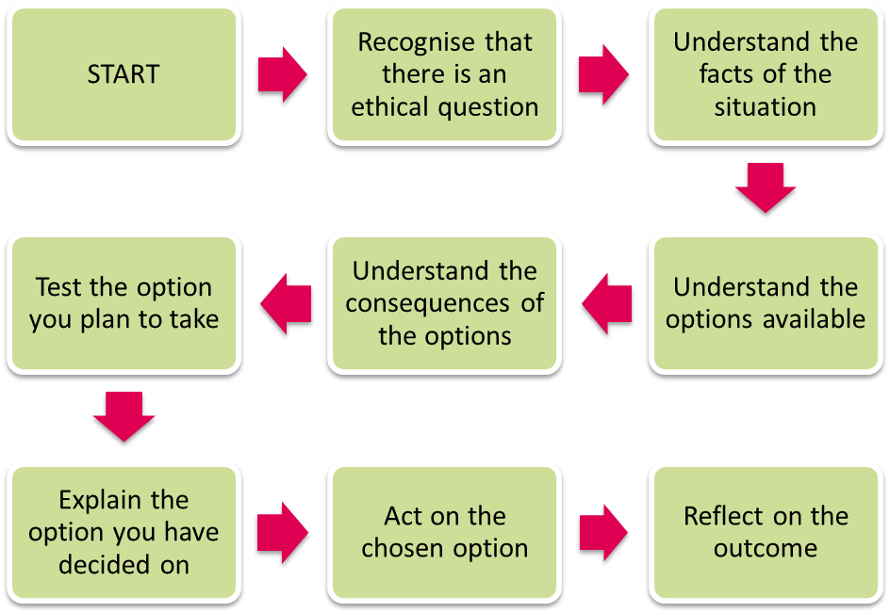

1. Recognise that there is an ethical dilemma
What is the situation?
Do I have choices?
What is at stake?

2. Understand the facts of the situation
What are the facts?
Do I need to find anything out?

3. Understand the options available
What are my options?
Do any laws/professional ethics influence my options?

4. Understand the consequences of the options
What are the consequences of each option?
Who will be affected by each option?
How will the parties be affected by each option?

5. Test the option you plan to take
Which is the best option?
Thoroughly review the preferred option:
Will the preferred option be difficult for others to understand?
Can I justify my actions?
How will I implement the decision?

6. Explain the option you have decided upon
Explain my actions – I should be able to justify them in a logical and straightforward manner
I should have kept records of my decision – now also keep a record of how I communicate my decision to those affected

7. Act on the chosen option
How will I implement my decision?

8. Reflect on the outcome
How did my decision turn out?
Who was affected and how?

